Ideation Phase
Define the Problem Statements

Date | 12 july 2026
Team ID | Vasundhara361@gmail.com
Project Name | Credit Card Approval Prediction
Maximum Marks | 2 Marks

Customer Problem Statement Template:
Create a problem statement to understand your customer's point of view. The Customer Problem Statement template helps you focus on what matters to create experiences people will love.
Problem  Statement (PS) | I am  (Customer) | I’m trying to | But | Because | Which makes me feel
PS-1 | A bank loan officer | Approve or reject credit card applications accurately and quickly | Manual evaluation takes time and may lead to incorrect decisions | Large numbers of applications and multiple customer factors must be analyzed | Frustrated and less confident in the approval process
PS-2 | A customer applying for a credit card | Get my credit card application approved quickly | The approval process is slow and sometimes inconsistent | Applications are manually reviewed using many financial criteria | Anxious and uncertain about the result
A well-articulated customer problem statement allows you and your team to find the ideal solution for the challenges your customers face. Throughout the process, you’ll also be able to empathize with your customers, which helps you better understand how they perceive your product or service.
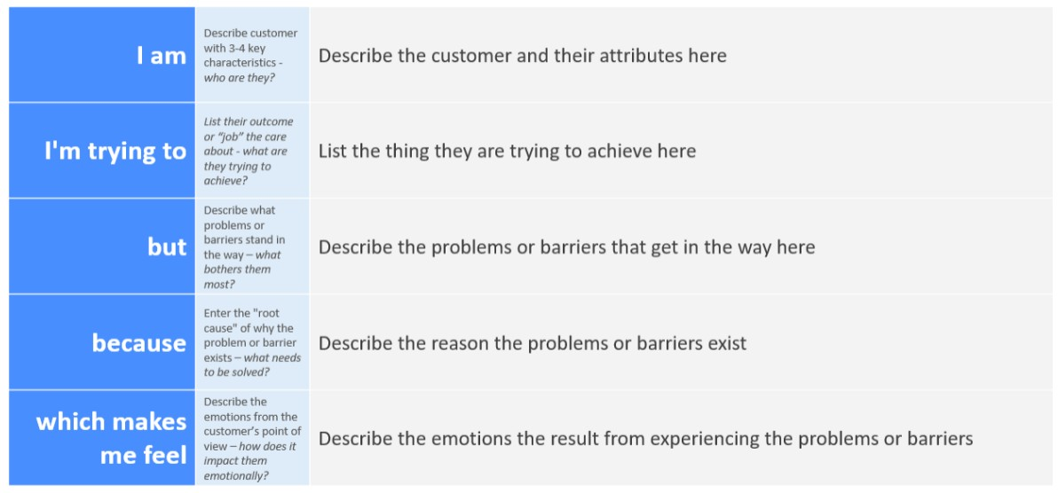
Reference: https://miro.com/templates/customer-problem-statement/ Example:
